Week One: October 14, 2020 - 1st Peter Overview

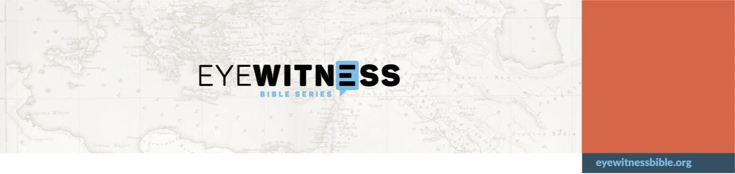
Episode: Other Letters Series No. 04 Narrator: Silas
Primary Scriptures: 1 Peter 1-5 Story Summary: Overview of 1 Peter Location: Roman Empire
Time: 60-64 AD
Suggested Memory Scriptures: 1 Peter 1:7-9; 2:1, 2:9, 2:12; 3:1-2, 3:7, 3:17; 4:7-8; 5:8-9
The letter was addressed from Peter the apostle. You can quickly see why some scholars wonder how the uneducated Peter of the gospels attained the language and theological skill to write this letter. Perhaps 1 Peter 5:12 provides part of the answer.
This letter was sent to faithful Christians in various areas of modern-day Turkey, but was likely meant for much wider dissemination. They had apparently been going through various trials, and Peter encouraged them to stay faithful, thereby obtaining salvation. Peter reminds them that Christ suffered, too.
Holiness is an important outcome of faithfulness and suffering. Peter tells them that they are to be holy because God is holy, and because God will judge each of them according to their deeds. He reminds them that they are specially chosen by God who called them. They are to behave honorably so that even unbelievers will glorify God.
Like Paul and James, Peter calls for believers to have submissive attitudes so they can bring others to Christ. They are also to have a desire for unity and a loving spirit. Over and over, Peter stresses the need for right behavior.
1 Peter 4:7 reflects one of the reasons why Peter is so forthright and urgent that people behave rightly. He says the end of all things is near. With that insight, Peter knows people need to change now, not at some point in the future when it might be too late. 1 Peter 4:8 shows just how much Peter has developed his thought process. He says to love each other deeply. Not just love each other, but love deeply. Why? Because love covers over a multitude of sins.
Another reason Christians are to behave rightly is that they are representatives of God. Peter urges his hearers to speak as if God is speaking, and serve with all the strength God provides. The end goal of this is one thing: that God is praised through Jesus Christ.
As Peter moves to conclude the letter, he reminds the elders to be good shepherds of their flocks. Although it happened nearly forty years earlier, you can be sure Peter remembers Jesus telling him to take care of Jes􏰀s􏰁 sheep.1
1 John 21:15-18
Discussion Questions:
- Name some reasons why this letter portrays a writer much more mature and educated than the Peter found in the gospels.

- To whom did Peter write this letter?

- What is the result of having faith in Jesus?

- Where is Jesus living now?

- Will people have to account to God for their deeds?

- Explain what it means to be humble as commanded in 1 Peter 5:5-6.

Application Questions:
- 1 Peter 1:14-15 says to be holy and not to conform to the evil desires we had before becoming believers. In your life, what does it mean to be holy and not follow evil desires?
- 1 Peter 2:9 says you are chosen and are God􏰁s special possession. According to 1 Peter 2:8-10, why is that so?

- Can you submit yourself to all human authorities for the Lord􏰁s sake? Which ones are you not willing to submit to? Why?

- Are you willing to follow 1 Peter 3:9? Who has offended you that need to repay with a blessing?

- What are some lessons you can you infer from 1 Peter 4:10?

- What kind of foe is Satan according to 1 Peter 5:8-9?

